Oliver Collins-Cope

2102775@rutc.ac.uk

Learning aim A

Examine systems and services that form part of the Internet of Things

UNit 19 Internet Of Things

Assignment 1

Contents

Introduction 2

**What is the IoT?** 2

What do we use IoT for? 2

**IoT Systems** 3

Home Sector 3

Health sector 3

Industrial and transportation sector 3

Retail and commerce sector 4

**Home Sector** 4

**Smart Doorbell** 4

*Purpose* 4

*How does it work?* 5

**Smart Lighting** 5

*Purpose* 5

*How does it work?* 6

**Health Sector** 6

**Remote Patient Monitoring** 6

*Purpose* 6

*How does it work?* 6

**Pacemaker** 7

*Purpose* 8

*How does it work?* 8

**Principles underpin the IoT** 8

Home Sector: Smart Light 8

Home Sector: Smart Doorbell 9

Health Sector: Remote Patient Monitoring 9

Health Sector: Pacemaker 10

**Characteristics of IoT systems and services** 10

Comparison of Home Sector 10

Smart Light risks 10

Smart Doorbell risks 10

Smart Lighting legal considerations 10

Smart Doorbell legal considerations 11

Smart Lighting sustainability 11

Smart Doorbell sustainability 11

Smart Lighting low mobility 11

Smart Doorbell low mobility 11

Smart Lighting time controlled 11

Smart Doorbell time controlled 12

Summary 12

Comparison of Health Sector 12

**Evaluation** 12

# Introduction

This report aims to examine the real-world impact of IoT systems, and the various components, applications, and challenges associated with these systems in the modern world. Furthermore, it will highlight specific scenarios where IoT systems play a crucial role in enhancing quality of life and, in some cases, even saving lives, particularly within the healthcare sector.

# **What is the IoT?**

While the IoT (Internet of Things) is a relatively new concept and idea, coming around only in the 21st century, there remains a lot to be said about this innovative technology. The IoT refers to a network of objects embedded with electronics, software, sensors, and connectivity which enables them to connect and exchange data. This encompasses a wide range of devices, including physical objects, vehicles, household appliances, and other items that meet the aforementioned criteria.

## What do we use IoT for?

The IoT (Internet of Things) is widely utilized across the globe, encompassing a diverse range of industries. There are several key sectors, including:

* Home Sector
* Health Sector
* Industrial and Transportation Sector
* Retail and Commerce Sector

The applications of IoT vary greatly based on the specific industry or environment for which it is designed and implemented. For instance, in the Home Sector, IoT may be used to control a remotely operated radiator, while in the Transportation Sector, the focus may be on advanced traffic management systems rather than smaller devices like a radiator or thermostat.

# **IoT Systems**

The Internet of Things systems have a significant impact across various industries, including the Home, Health, Industrial and Transportation, and Retail and Commerce sectors. The role of these systems varies depending on the specific situation, with each sector leveraging IoT systems to improve quality of life and other relevant aspects. The following provides examples of IoT systems utilized in different sectors.

## Home Sector

The rise of the Internet of Things has had a profound impact on our daily lives. With an increasing number of devices able to connect to the internet and be controlled remotely, we now have greater control over many aspects of our homes. From smart cameras and thermostats, to speakers, lights, and plugs, these IoT devices are making it easier to manage our homes and enhance our daily experiences. With the use of a mobile app, we can control these devices from anywhere, at any time, making our homes more comfortable, convenient, and efficient places to live.

## Health sector

In the health sector, the IoT has had a major impact. It has completely overhauled the way the patients are receiving care alongside aiding the medical professionals that are providing said care. Due to the increasing production and emphasis on IoT systems, there exists a not insignificant number of devices that help to monitor and manage health conditions, such as wearable fitness trackers, smart scales, and other medical devices. These systems collect data to be analysed and compared to previously available data that helps to identify any potential health hazards or issues the patient might run into. This promotes more personalised care that is catered towards an individual, increasing the quality of care they receive. Additionally, IoT systems have enabled patients to connect to medical professionals remotely for different procedures such as a consultation or follow up, such as seen with AskMyGP in the UK. Finally, this has allowed the healthcare system to be much more accessible for everyone.

## Industrial and transportation sector

The impact of IoT systems in the industrial and transportation sector is undeniable. IoT has transformed the way businesses and organizations operate, providing real-time data and insights on various systems. This has led to improved efficiency, reduced downtime, and increased productivity. IoT sensors, for instance, can monitor industrial machinery and vehicles, giving businesses valuable information on their performance and location. This optimizes processes and procedures, making operations more effective.

In transportation, IoT systems are used for tracking and monitoring vehicles, resulting in faster delivery times and increased road safety. Furthermore, integrating IoT can also help reduce fuel consumption and promote eco-friendliness in businesses.

## Retail and commerce sector

The retail and commerce sector has benefitted from the use of IoT systems in a variety of ways. However, there any many opportunities for improvement that can be found detailed below.

One example is the implementation of smart shelves, which keep track of inventory levels and let store managers know when stock is running low. Another is smart shopping carts that help customers keep track of their purchases and simplify the checkout process. IoT sensors can also be used in inventory management systems to monitor the movement of goods within a store. Electronic price tags, updated remotely with IoT, can eliminate the need for manual updates. Customer experience can be improved through the use of IoT sensors and cameras that gather data on customer behaviour. Predictive maintenance using IoT sensors can prevent equipment downtime. Contactless payment systems using IoT technology reduce the risk of infection and augmented reality displays provide customers with interactive product information and recommendations.

# **Home Sector**

## **Smart Doorbell**

A smart doorbell is a great example of an IoT system that is commonly used in the home sector. A famous example of the smart doorbell is the ring camera, which works through an application on the phone and an internet connection.

### *Purpose*

The purpose of the smart doorbell in the home sector varies depending on the person, however it follows the general idea of serving as a way for people to view their front door while not answering the door or not being home. Another purpose for this IoT system is to be used as a way to receive a parcel or speak to the delivery driver in order to request that a parcel is left inside or nearby, or any other instructions.

### *How does it work?*

The smart doorbell works similarly to most IoT systems. In this specific example of the Ring doorbell, it works by first being calibrated and connected to a network that is constantly operating nearby. This is most commonly done on a mobile device such as a phone or tablet, however some products may offer a desktop setup. Once the doorbell has been connected to a network, it is setup outside of a door and holds a sensor that works based on motion detection or button activation when someone would press a button on the doorbell to “ring” the doorbell. This then sends a notification through the internet onto a mobile device that also has an internet connection, and also has the specific software for the hardware, which in this situation is the doorbell. Once the notification has been received, the user can access the application and view the live camera feed, choosing whatever action they want, whether that be answering the door or talking to the person through the doorbell.

## **Smart Lighting**

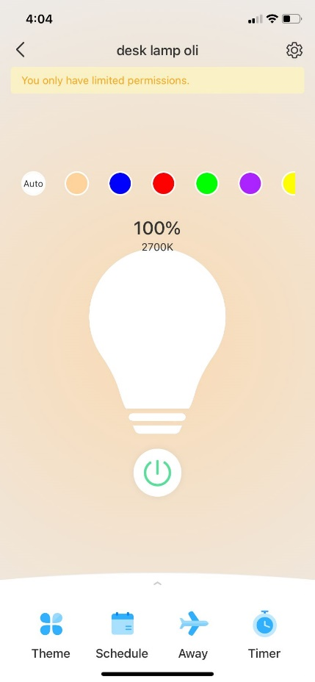Smart lighting is another great example of an IoT device that has come into the limelight recently. It provides people with a way to control lighting both inside and outside of the house, ensuring that money is not lost on electricity bills from the lighting. Additionally, these lights usually tend to be LEDs with multiple colour options, giving more life to peoples living rooms and many more.

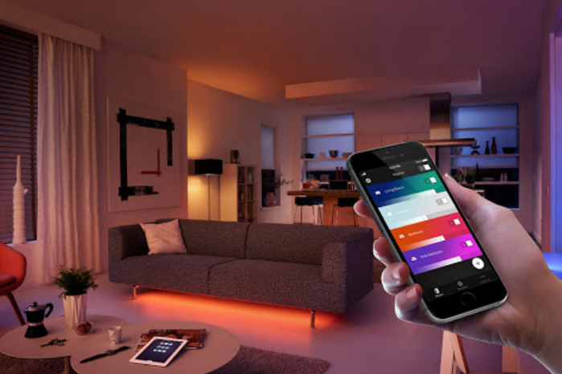

### *Purpose*

As mentioned above, the primary purpose of smart lighting is to provide people with a way to turn lights off and on remotely. This has a host of benefits that greatly improve quality of life, such as being able to control all the lights in the house from a mobile phone, and not having to worry about whether all lights are disabled once someone leaves the house as they can just check through their phone. They also tend to have an added benefit of offering multiple colour options and being LED lights.

### *How does it work?*

Smart lighting works similarly to the Smart Doorbell. Initially, the light is screwed into an empty light. From there, a user will have a specific application that they are required to download, the software, in order to connect to the light and calibrate it. Similarly, the light must be calibrated by being connected to the network so it has constant access to the internet. Once calibrated, the user is then able to send a signal through the internet containing the instructions for the light that they accessed through the application, such as turn on, turn off, change colour, and change brightness.

# **Health Sector**

## **Remote Patient Monitoring**

Remote patient monitoring is one of the most recent inventions from the health sector that allow clinicians and technicians to monitor patient’s health from remote locations such as their office. It works as a way for patients to remain out and about while also remaining monitored, giving them more freedom in their life but not sacrificing their safety, security and health.

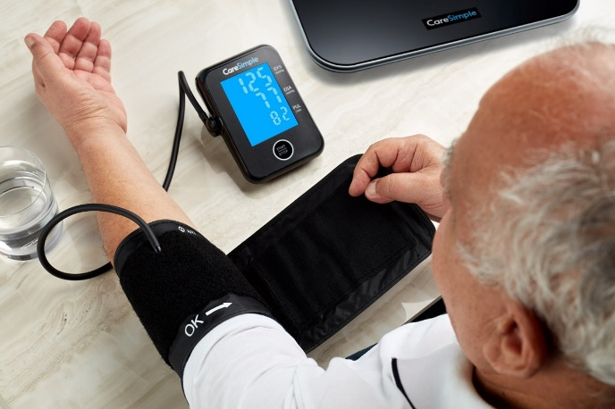 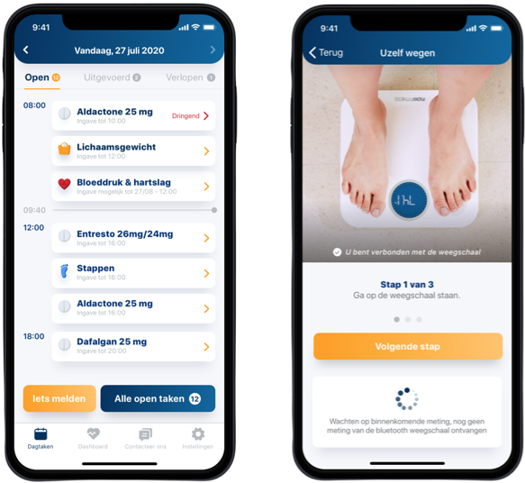

### *Purpose*

The purpose of remote patient monitoring is to communicate important information about patients to clinicians and technicians, and once this information has been communicated then the healthcare professionals are able to make adequate and important decisions while being well informed. Finally, this is a great way for patients to continue to live their life while not jeopardising their health and the quality of any reports they might have to make about it.

### *How does it work?*

Remote patient monitoring works by connecting to a mobile device through a network like Bluetooth or 4G, and then transmits the necessary data to the hospitals and healthcare professionals. One device that tracks information like this is a weight scale, and another example is a blood pressure monitor. This is accomplished by connecting these to the network or mobile device, which sends the information to the hospital without any input from the patient.

## **Pacemaker**

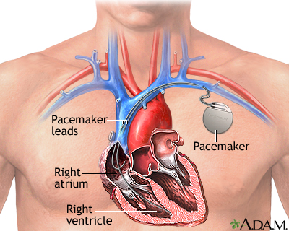 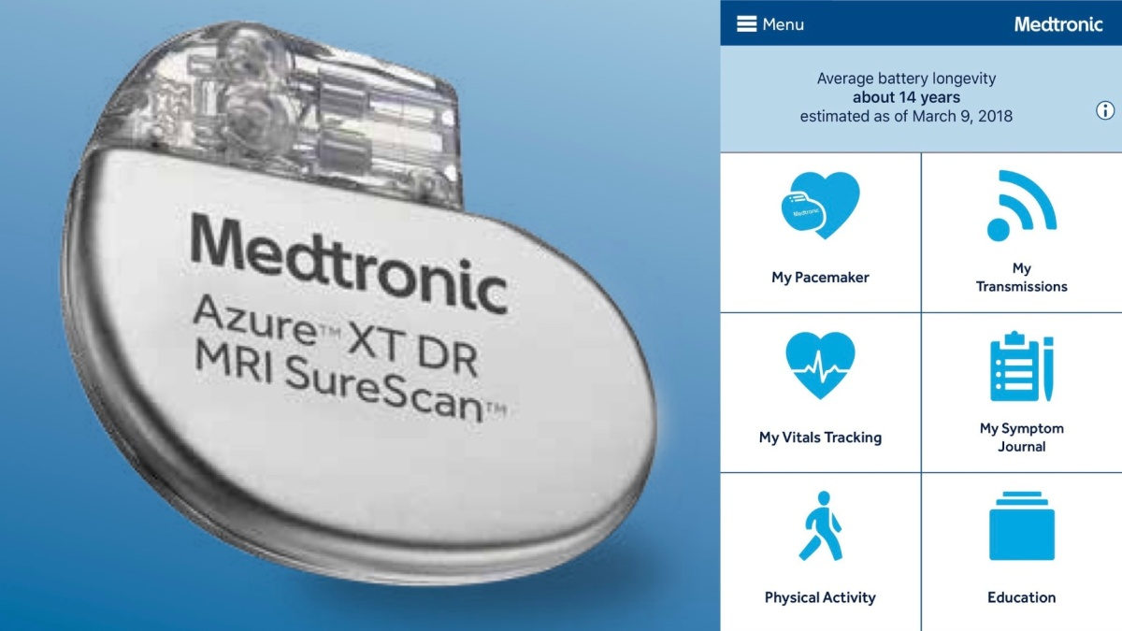

A pacemaker is a vital piece of IoT that works inside of patients to send electronic pulses to your heart to keep it beating at a regular and adequate speed in order to make sure that your heart is functioning properly, and there are no issues with your heartbeat. This is a device that can be crucial in improving people’s quality of life if people have issues with slow heartrate and for others, it can be lifesaving.

### *Purpose*

The purpose of a pacemaker is described as above. It works to keep the heart beating at a constant and regular pace to make sure that it is not too slow. This can prevent a number of issues, most notably, a slower heartbeat which can greatly impact someone’s ability to live a normal life. It causes issues such as chest pain, confusion, memory problems, and dizziness or light-headedness.

### *How does it work?*

A pacemaker works by being installed just above someone’s heart under their collarbone, and senses, using wires, whether or not the heart is beating fast enough. If it is not, or it misses even a single beat, it sends an electrical pulse to the heart, causing it to beat. Recently, pacemakers have had options to connect to a network, giving information to doctors and healthcare professionals about the patient data and information regarding their heartbeat. This is calibrated before it is installed by the healthcare professional/hospital employee.

# **Principles underpin the IoT**

## Home Sector: Smart Light

A smart light bulb is a great example of an IoT device that showcases the principles of IoT systems and services. The smart light bulb connects to a mobile application and operates through the following principles:

First, the smart light bulb collects data on the light levels in the room and analyses it. From here, it can perform actions such as turning on or off based on the user's preferences.

The smart light bulb relies on the existing internet and telecommunications infrastructure to allow the user to connect to the device and allow them the ability to manipulate the lamp.

It must access real-time to respond to changes in the environment such as it becoming darker or brighter.

The smart light bulb has access to analogue data from the physical world, the user to make decisions such as automating levels based on light or timing.

It has always-on connectivity, allowing it to continuously monitor the light. Finally, it covers the spectrum of insight five-phase data flow in real-time.

This process allows the smart light to make accurate decisions based on following the process.

## Home Sector: Smart Doorbell

A smart doorbell is another example of an IoT device that demonstrates the principles of IoT systems and services. The smart doorbell operates through the following principles:

The smart doorbell will collect data on who is at the door and send a notification to mobile device.

To further that, the smart doorbell needs access to the internet in order to be able to send the notification or live feed to the mobile device.

Using access to and analysis of the real time data the smart doorbell might be able to make decisions based on the results of this.

It has access to audio and video data that it is then able to transmit to the mobile device for the user to view and access.

It must have always on connectivity as this allows the device to be constantly on and continuously monitor the camera feed that it can send to the user.

The spectrum of insight allows the smart doorbell to follow the five phases to analyse and model data for the user and store it in an archive.

## Health Sector: Remote Patient Monitoring

Remote Patient Monitoring (RPM) is a healthcare application of IoT technology that demonstrates the principles of IoT systems and services. RPM operates through the following principles:

The RPM collects and analyses patient data and uses this to perform functions such as sending an alert to the healthcare provider if the data is outside of normal ranges.

RPM relies on the existing internet and telecommunications infrastructure to function properly, otherwise the RPM would not be able to send or transmit any data, as well as not being able to monitor accurately.

RPM has access to real time data that it must transfer to medical professionals, and without this access to the data it would be unable to send anything regarding the patient to the medical professional. Furthermore, it must analyse the data to ensure that it only transmits important information or alarming anomalies.

RPM has access to analogue data from the physical world, perhaps such as time of day and light levels. This could be used to monitor sleep schedules, etc.

RPM has always on connectivity as without it there may be times when the patient is unmonitored and something dangerous could occur, meaning it is vital to ensure it is active.

RPM uses the five-phase spectrum of insight to continuously monitor the patients data and ensure that nothing out of the ordinary happens to them.

## Health Sector: Pacemaker

A pacemaker is a medical device that demonstrates the principles of IoT systems and services. The pacemaker operates through the following principles:

The pacemaker must collect and analyse data on the patient's heart rate and rhythm to make sure that all their needs are being met, such as sending an electric shock when the heartbeat is not functioning properly.

It relies on the internet and infrastructure to transmit any data or information it collects to the medical professionals about the patients.

The pacemaker has access to real-time data to ensure that medical professionals are able to monitor and react to any changes in the patient’s heartbeat effectively and efficiently.

It uses analogue data to track real world variables like time and light levels, to ensure that all the data it is monitoring is accurate, such as when the patient is exercising or going through heartbeat increasing activity.

The pacemaker must have always on connectivity otherwise the patient’s life could be at risk due to not sending the information to the healthcare professionals if something occurs and not providing the correct shock to ensure the heart beats properly.

The spectrum of insight allows the patient data to be monitored accurately and analysed, before being archived for future use and to compare against the patient’s current health.

# **Characteristics of IoT systems and services**

## Comparison of Home Sector

### Smart Lighting risks

There are minimal risks associated with a smart lighting system as the consequences of the device being breached are minimal.

There are no risks such as payments being compromised, or the data being extracted.

### Smart Doorbell risks

This is completely different to the smart doorbell which monitors camera feed and if the data is compromised then there is a chance of someone being able to monitor the camera feed and viewing the contents of it.

This could provide them information like the camera’s address/location.

### Smart Lighting legal considerations

Within a smart lighting system there are not many legal considerations that have to be considered when talking about the incidents that might occur.

The only data that might be collected without consent could be a login details for the application, and other than this there is nothing that should be of issue.

### Smart Doorbell legal considerations

Contrary to smart lighting, smart doorbells have many legal considerations that must be observed due to the impact of them.

For example, the same issue of data collection if much larger with a smart doorbell, due to the ability to record footage and information, and this could be illegally or unethically monitored by an outside individual.

This could eventually lead to information/date of the footage being stolen or viewed by others without consent, and this is a legal consideration that has much significance.

### Smart Lighting sustainability

The smart lighting does have sustainability considerations as it is something that uses power continuously and therefore the sustainability of running a light is important to consider.

However, the smart lighting often provides options to control the light from outside of the home, or set up timed schedules, which provides many options to ensure that the light is very sustainable and therefore is great for this.

### Smart Doorbell sustainability

The smart doorbell is similar to this as it provides the option to control the device remotely. This means that the smart doorbell is able to be turned on and off when away from home and therefore helps to remain sustainable.

Furthermore, smart doorbells are often motion activated and only turn on when someone or something triggers the motion detection software, saving power and making it more sustainable by only being used when needed.

### Smart Lighting low mobility

A smart lighting system has little to no mobility, only moving around if the light bulb is to occupy another spot or when being set up.

Additionally, the only device the smart lighting has a connection to, the application that controls it, will only move around when the user moves with the application, however due to the fact that it is an application and not the physical IoT item, the smart lighting does not move.

### Smart Doorbell low mobility

Similarly to a smart lighting system, a smart doorbell system has no mobility as it is installed into one location and will remain that way until it is either moved for a specific reason or uninstalled.

Also similarly, the application is the only thing that will move around connected to the smart doorbell, but this does not count as the actual IoT system and therefore it does not move.

### Smart Lighting time controlled

A smart lighting system does often have the ability to be time controlled and therefore falls under this category.

The smart lighting application associated with the IoT system means that it has the option to set up predetermined time system that changes the lights based on what time it is to any setting that was established.

### Smart Doorbell time controlled

In comparison to the smart lighting system, the smart doorbell has no obvious time control settings.

There are no settings or functions that could be created either for the smart doorbell, as it is a system that relies on being constantly activated in order to do its job properly, i.e., monitoring motion.

### Summary

These are all of the characteristics that apply to the home sector IoT and compares them.

There are more options available that could be applied however it would result in both of the IoT devices not being able to be applied to the characteristics and would add a lot of unnecessary sections.

## Comparison of Health Sector

### Remote patient monitoring risks

There are some risks associated with remote patient monitoring as this field involves highly sensitive data and information that includes your medical history, and therefore there is a risk of unauthorised access of this data.

For example, some of the sensitive data could include things like: heart rate, body mass index, weight, and any other health conditions like illnesses or mental health disorders.

This puts the patient’s medical history and monitored data at risk of exposure.

### Pacemaker risks

Similarly to remote patient monitoring, there are risks associated with pacemakers.

This is contrary to the remote patient monitoring which is not as life threatening, however as pacemakers start to become IoT enabled, there is a risk of them being hacked and controlled, leading to the hacker potentially putting the patient in life threatening complications by modifying the pacemaker.

Finally, they could also access any data and information that is being transmitted by the pacemaker, leading to patient medical information being stolen, which is similar to the remote patient monitoring.

### Remote patient monitoring ethical and privacy considerations

### Pacemaker risks ethical and privacy considerations

### Remote patient monitoring legal consideration

### Pacemaker legal considerations

### Remote patient monitoring sustainability

### Pacemaker sustainability

### Remote patient monitoring benefits

### Pacemaker benefits

# **Evaluation**